**Year 5 Homework - Friday 26th Sept 24**



Our topic in Geography this half term focusses on population changes around the world. This week we have been looking at the UK. Can you use an atlas, the internet or what you already know to write the names of at least 10 towns, cities or counties on the map?

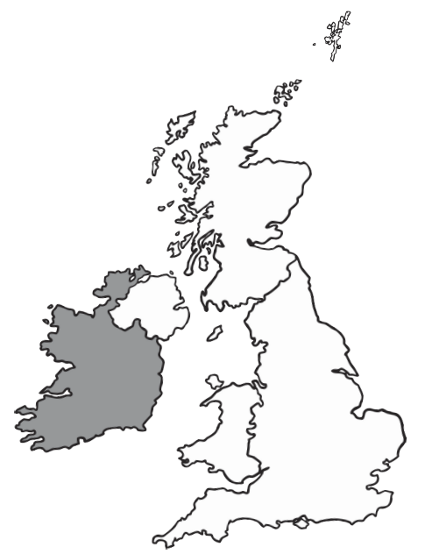

**Homework due in - Thursday 3rd Oct 24**